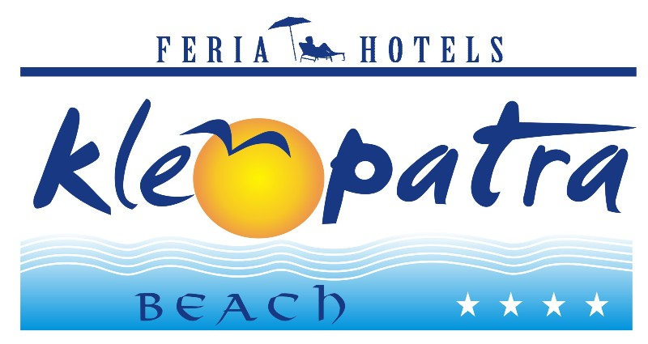 KLEOPATRA BEACH HOTEL **** ALANYA- ANTALYA, TURKEY

MORE INFORMATION

Check-in Time | 14:00
Check-out Time | 12:00
Number Of Floors | 5 – 6 ( 3 buildings )
Number Of Rooms | 208
Year Of Construction | 1993
Last Renovation | 2014
Address | Ataturk Caddesi 1500 Sokak Alanya-Antalya
Tel | 0 242 512 80 91
Fax | 0 242 512 80 92
E-mail | sales@feriahotels.com
Web Site | www.feriahotels.com

CONTACTS

Title | Mr.
First Name | Ali Kayhan
Last Name | Demir
Position | Sales & Marketing Manager
Phone | 0 242 512 80 91
Fax | 0 242 512 80 92
E-mail | sales@feriahotels.com
Address | Ataturk Caddesi 1500 Sokak Alanya
City | Antalya
Zip code | 07400
Country | Turkey

GENERAL HOTEL INFORMATION

Kleopatra Beach Hotel is located in Alanya; it takes 1 km to the center,30 m to the beach, 118 km to Antalya Airport .
Taxi and minibus are available for your transportation.
The hotel has 203 rooms including 420 beds totally.

Address: Ataturk Caddesi 1500 Sokak No:1 Alanya – Antalya / Turkey

ROOMS

Standard Rooms
Rooms are about 22-24 m2 and ceramic and Carpet flooring. They have a bedroom including split air condition, satellite TV, music channel, sofa, safe box (with extra charge), telephone, mini bar (with extra charge), a bathroom including shower, WC and hair dryer, a balcony. They have minimum 2 pax and maximum 3+1 pax capacities. Room service is also available 08:00 – 24:00.

AMENITIES

Features (free of charge)

Outdoor Swimming Pool

Outdoor Kids’ Pool
Baby cot
Sun beds (by the pool)
Sun umbrellas (by the pool)
Mattress (by the pool)
Sea (sandy)
Beach (sandy)
Breakfast, lunch and dinner
Elevator

TV Hall
Aqua swimming pool
Meeting room 105 people capacity

Sports & Activities
Billiard-Table tennis, beach volley
Turkish bath, sauna, massage, beauty centre (all with extra charge),
Water Sports (all with extra charge),
Animations and shows (two times in a week)

BARS & SNACKS

Pool Bar
Service hours are between 10:00 and 00:00.
(All inclusive: 10:00-23:00 o’clock)
It’s not allowed to serve alcohol drinks under 18 years old guests.

Restaurant Bar
Service hours are at dining times.

Beach Bar
Service hours are between 08:00 and 17:00.

DINING

Restaurant
The restaurant has 80 pax indoor with air condition and 340 pax outdoor capacities.

Breakfast 08:00 – 10:00 (Buffet)
Snack at Pool 10:00 – 12:30 & 14:00 – 17:00 (Pool)
Lunch 12:30 – 14:00 (Buffet)
Café and cake 17:00 – 18:00 (Pool Bar)
Dinner 19:00 – 21:00 (Buffet)

GOOD TO KNOW

Not included in the Package
Doctor
Mini bar
Safe box
Sun beds (on the beach)
Sun umbrellas (on the beach)
Mattress (on the beach)
Sauna
Beauty centre
Water sports
Laundry
Wi-fi
Special Packages
Wedding
Honeymoon

